ICFC Project Progress Report (v.5)

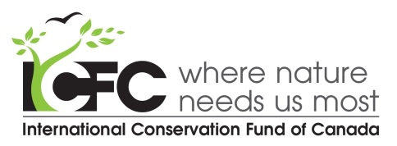
Note: You can either fill in this form or use it as a guide for a report done in your own format. There is no length limit, except for the Summary section.
Please avoid repeating information in different sections (thanks!).

[Project Name]
[Your Name]
[Project Reporting Period]
Date submitted:

SUMMARY OF PROGRESS AND OUTCOMES
Please briefly (in one page or less):

1) List key results for the reporting period.

2) State any significant unexpected bad developments and good developments.

For year-end and project-end reports, please let us know somewhere in this summary how the project has affected the conservation status of the species/land/ecosystem (as applicable), compared with what it would have been if the project had not taken place. Or what ground work has been accomplished toward that end.

PROJECT narrative
Here you may present a more detailed narrative of activities and achievements.

CHALLENGES
Describe any challenges (not already described above) that have impacted (or may impact) the project and explain how you addressed or plan to address them. Or check below if applicable.
Challenges are described in the Project Narrative. □
There are no particular challenges presently. □

ARE THERE ANY changes to EXTERNAL funding?
If there are any changes from the most recent budget in funding from other sources, please let us know that here. We need to know what portion of a project’s total budget we are funding and who the other funders are (so that we can give them credit).
There are no changes. □

APPENDICES

Please attach any supporting materials (e.g. maps, additional photos, tables).

ICFC would much appreciate receiving a selection of high resolution photos that we can use in our annual report and newsletters. Lower resolution photos are also useful for our website. Please supply photo credit info for each. We find Flickr a great way to share photos, by the way.

